JazzNights (69)

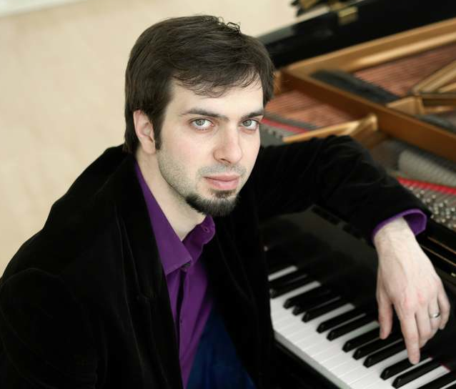
Chris Ziemba studied with the best, privately with Paul Hofmann in Rochester, then Harold Danko at Eastman, Fred Hersch, Brad Mehldau and, most recently at Julliard with Frank Kimbrough. Indeed, it was Frank who first told me about this talented young man. He won the 2011 Jacksonville Jazz piano Competition and has begun to appear on recordings – most recently Ted Nash’s Chakra in 2013. His three CD duo piano recording (with co-leader Paul Hofmann) Who Knows? will appear this summer on MHR Records. I haven’t heard it yet (samples are available at http://www.mhrrecords.com/catalog/cd21-23.html) but the tunes range from Ellington (Who Knows?) James P. Johnson (the wonderful You’ve Got to be Modernistic) to bop standards by legendary pianists (Barry Harris Nascimento), Lennie Tristano, Elmo Hope, Bud Powell, Sonny Clark).

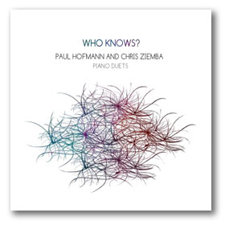

Hofmann writes:

Much of this music combines jazz and classical sensibilities, harmonies, techniques and outlooks. Breaking down barriers between musical styles has been one of the passions of my musical life; and many of the composers represented here shared (or still share) the same vision. As such, the material on “Who Knows?” constitutes a somewhat comprehensive survey of many of the great composer-­pianists in jazz history.

I last heard Chris at Kitano last March where his program included jazz standards, a few originals, and an absolutely stunning presentation of Jimmy Rowles’ Peacocks.
A. G. Zaire commented on that evening: “He plays this standard [While We’re Young] very well, lots of variation in time, complex riffs on this chestnut. Strides out…. Excellent.”

Mr. Ziemba is definitely on the rise, you will be hearing much from him – and you can get in on the ground floor September 11!

