JazzNights (89)

On Friday, September 21, 2018, JazzNights is pleased to present the Ron Horton quartet: Ron Horton on trumpet and (probably) flugelhorn, pianist Frank Kimbrough, bassist Dean Johnson, and drummer Michael Sarin. The event will be held at 8 pm at the Hockaday/Jones Barn at 78 Moores Mill Mt. Rose Road in Hopewell. Directions are posted on our website. We are asking for a contribution of $55 per person. Please Note – for this concert only the contact person is not Mary Wisnovsky. We expect to return to “normal” for the next one. So, please email your reservation to Mait at mjjr@princeton.edu, or simply reply to this message.

In an effort to save paper and mailing expense, as well to give us an idea of attendance numbers sooner rather than later, we ask those of you who email responses to write out a check payable to Maitland Jones for the appropriate amount ($55 per person) and mail it to him at 78 Moores Mill Mt. Rose Road, Hopewell NJ 08525.

Note: If you reserve now but later find that you can't make it, please let us know right away. We often have a waiting list and can use the space, sometimes even at the last moment. We try to keep the costs as low as possible and "no-shows" inevitably raise the price to others in the future.

The Ron Horton Quartet features four brilliant musicians who have played together for years in various combinations. I suspect I first encountered Mr. Horton on hearing “Dusk,” Andrew Hill’s remarkable CD from 1999. He’s featured on this disk, which is on many critic’s list of the best jazz recordings. If you don’t know it, you have a treat in store and Mr. Horton will be a big part of it. Andrew Hill’s music has been a focus of Horton (and Kimbrough and Johnson) for years, and over that time I have been lucky enough to hear them many times. In November of 2016, all four members of this quartet were at the Stone (with Marty Ehrlich and Marc Mommaas) playing Hill’s music to an audience that included Joanne Hill, Andrew’s widow. It was a wonderful evening that began with a performance of “Dusk”, and my notes repeatedly single out Mr. Horton’s playing.
“10 bazillion [that’s a technical term we quantitative types use] stars for RH’s solo” was a typical comment. Earlier, in September at the Jazz Standard a group led by Kimbrough that featured Horton and Ehrlich, opened with “Dusk” in a very different version. Will we hear it this September in still another take on this most atmospheric tune? I hope so.

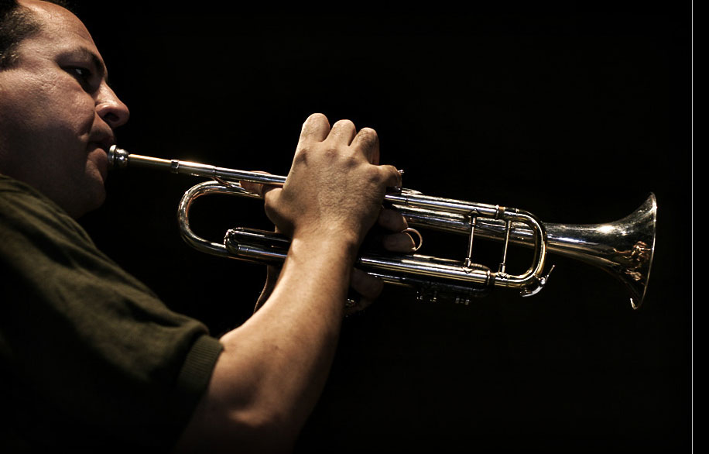

“Epitomizing the new face of the creative mainstream, Horton is equal parts swinging hard bop stylist, modern classicist and exploratory avant-guardist.”
Tony Collins, Allaboutjazz

The pianist in this group, Frank Kimbrough, is one of the most versatile and brilliant of today's pianists. He is not only a superb leader, but an accompanist of note - always a good sign. Think of some of the great accompanists - Tommy Flanagan, Bruce Barth, and Kenny Barron come quickly to mind - not a bad start to an all-star list! One of my most memorable times hearing Mr. Kimbrough live was his May, 2006 duet evening with his long-time teacher-associate-hero Paul Bley at Merkin Concert Hall. The review in the New York Times the next day was luminous and the performance made Time Out’s list of the best performances of the year. I couldn’t agree more; it was spectacular, on-the-edge music. As I’ve said here (too?) many times, one of the big attractions of this wonderful music is its without-a-net, in-the-moment dangerous aspect. Here’s what Kimbrough himself has to say on that subject:
“Music should be a living, breathing thing. Maybe you put yourself into a situation sometimes where you might be terrified. You might be one millimeter from failure. That’s alright because in those situations you’re very present.”
Dean Johnson’s musical sensibility was molded by a ten-year association with Gerry Mulligan, and he has performed with many of todays best: Lee Konitz, Wynton Marsallis, Steve Kuhn, Joe Lovano, and Dave Douglas. In December, Mr. Johnson will return to JazzNights leading his own group. My notes from the 2016 Stone gig single him out several times: Here’s just one, “DJ so good! Complex, slurs, chords – excellent.”
Michael Sarin has appeared at JazzNights twice with Leslie Pintchik (2013 and 2017). If you caught one of those concerts you know what to expect from Mr. Sarin – virtuosity coupled with taste – musical drumming.
So, please join us this September; you will love this group. Promise.

