JazzNights (90)

On Sunday, November 4, 2018, JazzNights will present a marvelous duo: Marc Mommaas and Nickolaj Hess.

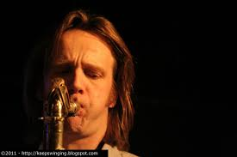
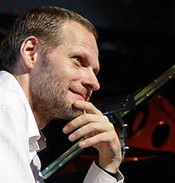
Mommaas Hess

Jazz is the quintessential American artform, right? Well, not these days. Jazz has spread throughout the world, and New York is filled with musical expats from all over the globe. In JazzNights 90 we present a Dutchman and a Dane who play this American music especially beautifully.

Tenor saxophonist Marc Mommaas and pianist Nickolaj Hess have been playing together for years, establishing a rapport that is apparent in every tune they play. Their connection comes through especially clearly in ballads. Their 2016 CD (with appearances by Vic Juris and Tom Morgan) “Ballads and Standards” is essentially a masterclass in how to play ballads. It has become one of my favorites and I go back to it over and over. I cannot recommend it highly enough. Five standards are accompanied by two jazz icons, Jimmy Rowles’ “The Peacocks” and Thelonious Monk’s “Ask Me Now.” Doubtless we will hear some of those tunes in November (reliable inside information).

“The mastery of Mommaas and Hess completely overwhelms any feeling of normal. This is art of the highest standard, and a record which will most definitely be a “best of” 2016.” All About Jazz, 2016

Marc came to New York in 1997 from The Netherlands, having graduated from the Rhythmic Music Conservatory in Copenhagen and the Conservatorium van Amsterdam. His recording debut was in 1999, in a trio with Hess and bassist John Hebert. Many gigs and recordings followed, of course, in a vast variety of formats, ranging from solo saxophone to extended suites incorporating a string quartet.

“A fearless improviser…Mommaas has the ability and sense of spontaneous composition to start from almost nothing and build solos that were alive with energy and commitment, fairly bristling with power.”

John Kelman, All About Jazz

Pianist Hess graduated from the Rhythmic Music Conservatory at 22, with the top grade for piano performance, and is now a professor at the RMC. He’s lived and studied in Africa and is the winner of many prizes and awards. He divides his time between Copenhagen and New York.

Mommaas and Hess will be at the Deer Head Inn the night before JazzNights 90, and will be touring Scandinavia and Japan afterward. But you don’t have to travel further than Hopewell to hear this fabulous duo. Hope to see you there.

Highly recommended CD:

Ballads and Standards, Marc Mommaas, Nickolaj Hess, Tom Morgan, Victor Juris, Sunnyside, SSC 4024

